Scripture: 2 Kings 6:8-23
Memory Verse: Psalm 91:11 “….For he will command his angels concerning you
to guard you in all your ways…”
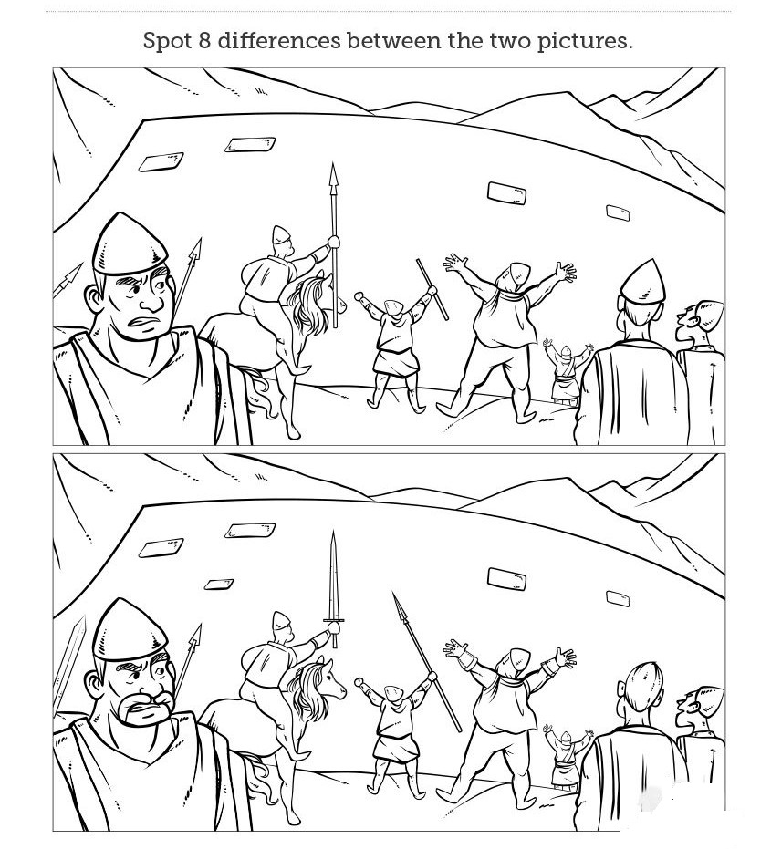
Today I learnt that I can trust God because He is able to protect me!

