Scripture: 2 Kings 5:1-16
Memory Verse: John 3:16 “…. For God so loved the world that he gave his one and only Son, that whoever believes in him shall not perish but have eternal life…”

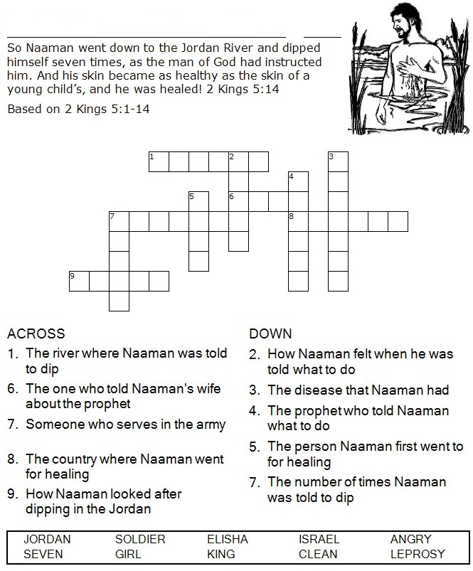
Today I learnt that I can be a witness for Jesus!

