Scripture: 2 Kings 6:24—7:16
Memory Verse: John 5:24 “….Very truly I tell you, whoever hears my word and believes him who sent me has eternal life…”
Guide the lepers through the maze to the Syrian army
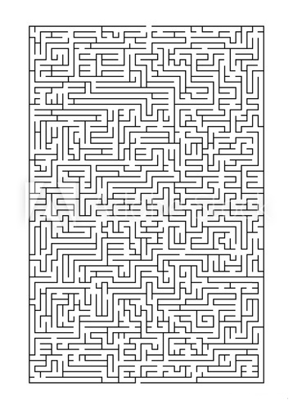
Today I learnt that when I believe the good news I will be saved!

