Scripture: 2 Kings 4:1-7
Memory Verse: Matthew 6:8 “…. Do not be like them, for your Father knows what you need before you ask him…”
Find the words given below in the wordsearch puzzle
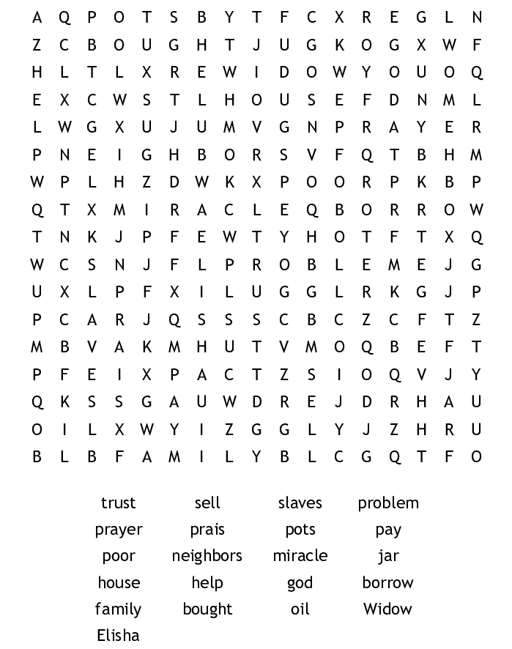
Today I learnt that God wants me to trust Him as He knows and will provide for me all I need!

