Scripture: 2 Kings 2:13-25
Memory Verse: Hebrews 13:17 “…. Have confidence in your leaders and submit to their authority…”
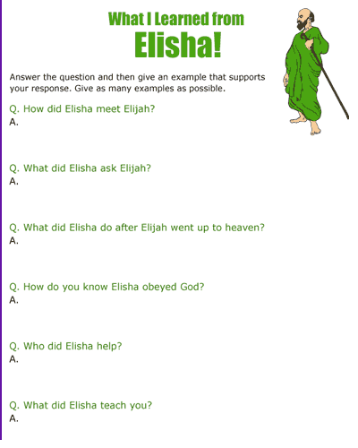
Today I learnt that God wants me to show respect for His workers!

